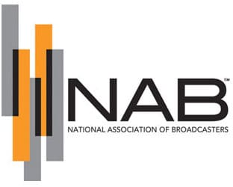

**SUPPORT LOCAL MEDIA**

The COVID-19 pandemic has shown that when we face our largest challenges, one of our greatest needs is access to ***reliable news and information***. That is why your local newspapers and radio and television broadcasters are critical components to the nation’s COVID-19 response. Yet our continued ability to serve your communities is being undermined by the financial harm posed by the current crisis.

In this moment, local newspapers and radio and television stations are working around the clock, often in dangerous conditions, to consistently get ***critical and timely*** information to the public. News publishers and local broadcasters have maintained their operations, provided a wide range of information at no cost, worked to protect employees in often dangerous conditions and – most of all – kept isolated individuals and families connected to their communities.

Unfortunately, the rapid and likely continued drop in advertising revenue from local businesses resulting from COVID-19 is having an immediate impact on publishers’ and broadcasters’ basic capacity to maintain their operations. Unlike many industries, the business proposition for locally-focused media - and local journalism in particular -was challenged *before* the pandemic. That situation has only worsened.

**Local news operations are in immediate peril due to COVID-19 and we need Congress to act now.**

* **Ensure the Ability of Local Media to Seek Relief Under the PaycheckProtection Program:** Many local media and news organizations (those with a majority of their audience within a single community or metropolitan area) exist within larger business groups. Regardless of their ownership, they all provide critical information to local communities and have been similarly harmed bythe COVID-19 crisis. Local news publisher and broadcaster eligibility for the newly-established Paycheck Protection Program relief must be determined at a local level (based on the local newspaper publisher or station) using a similar framework applied to restaurants and hotels.
* **Fund Federal Advertising Spending on Local Media:** Local broadcasters and newspapers can provide the federal government with unparalleled reach to provide critical information to communities across the country. Whether it is asingular unified national message or a locally-focused call to action, Congress can ensure that the people have the information they need most by directing current U.S. government advertising campaigns (such as those promoting the Census) to local news and media outlets, and providing the Department of Health and Human Services, the Small Business Administration and other relevant agencies with an additional $5 to $10 billion for direct funding for local media advertising. These ads could carry information on medical resources, status of testing sites, data from the Centers for Disease Control, mental health awareness, access to small business loans and other critical governmental information. **Advertising spends should be distributed across local media sectors and equitably allocated across large, medium and small communities.**