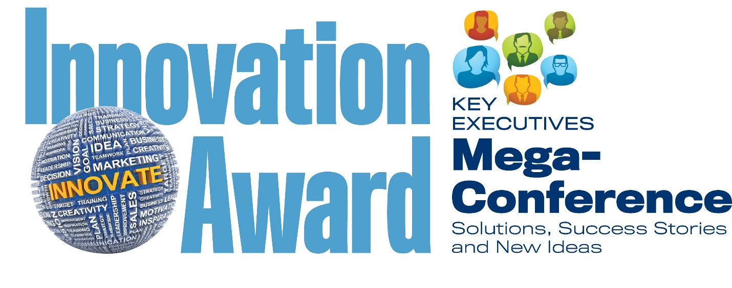
Sponsored by Inland Press Association, Local Media Association, the Southern Newspaper Publishers Association and News Media Alliance

Deadline for entries is 11 p.m. (Central) on Tuesday, January 15, 2019
There is NO entry fee.
Please complete those questions below that pertain to the innovative idea that you are nominating. After completing your entry, please email this document to cindy@snpa.org. Thank you!

Newspaper or company name:
Address:
City:
State:
ZIP:

Entry submitted by:
Title:
Email address:
Phone:

NEW REVENUE CHANNELS
What new product(s) or approaches have you introduced in the past 3 years that is/are making a significant difference in your business model today or is expected to significantly alter your business model in the near future? In addition to a description of your products or approaches, please provide links to showcase examples. If you would prefer to mail 10 printed samples, email cindy@snpa.org for the mailing address. (300 words or less, suggested)

BUSINESS MODEL TRANSFORMATION
Digital Revenue:
My digital revenue was _____ percent of my TOTAL REVENUE over the past 12 months.
Digital revenue at my company grew _____ percent this past year over the previous year.

NON-CORE REVENUE
Have you diversified your revenue in other ways beyond print and digital, such as events or agency services (PR work, logo development, competitive media placement, etc.)?
_____Yes
_____No
If yes, what percentage of your total advertising revenue comes from these streams? _____
What do you expect it to be in three years? _____
Please provide any additional details or comments that you would like the judges to consider (300 words or less, suggested).

AUDIENCE DEVELOPMENT
Please describe any innovative audience approaches your company has taken that has allowed your company to reach more readers, new audience segments (for example: Millennials, sports fanatics, etc.) or improve subscriber engagement. How has this impacted subscriptions, open rates, social shares or total audience? (300 words or less, suggested)

SALES & MARKETING APPROACH
Which of the following applies most to you?
_____We have trained all sales executives how to sell digital products.
_____We have a separate staff to sell digital and/or new initiatives.
_____We have specialized people who sell the complicated stuff and help the rest of the staff sell our new and/or digital product mix.

Please describe any innovative sales and marketing approaches you have taken that have helped your company improve the trajectory of your revenue (300 words or less, suggested)

ORGANIZATIONAL & COMPANY CULTURE TRANSFORMATION
Please describe how your company has changed its organizational structure, work environment and/or rewards to encourage innovation. (300 words or less suggested)

